1. Enter below Cigna link in Chrome browser

<https://hcpdirectory.cigna.com/web/public/consumer/directory/search?consumerCode=HDC001>

1. Enter the zip code in **Find a doctor** search box and select required Location from dropdown

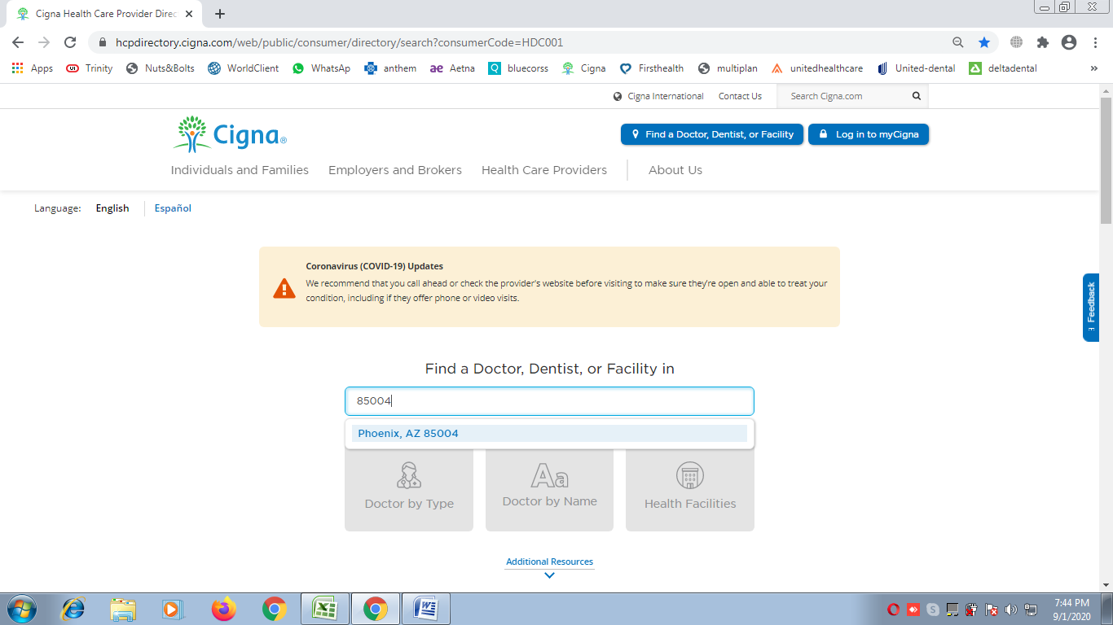

1. Click on **Doctor by name** and enter provider name here, multiple provider list would appear, Select the correct provider name form list

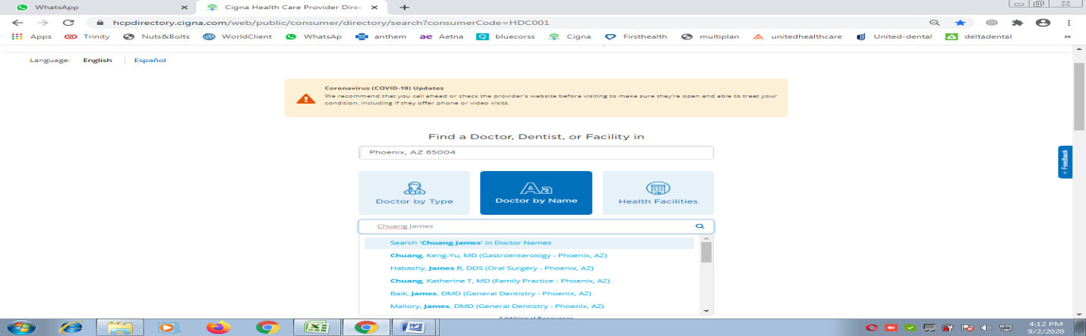

1. Next window would be like below. 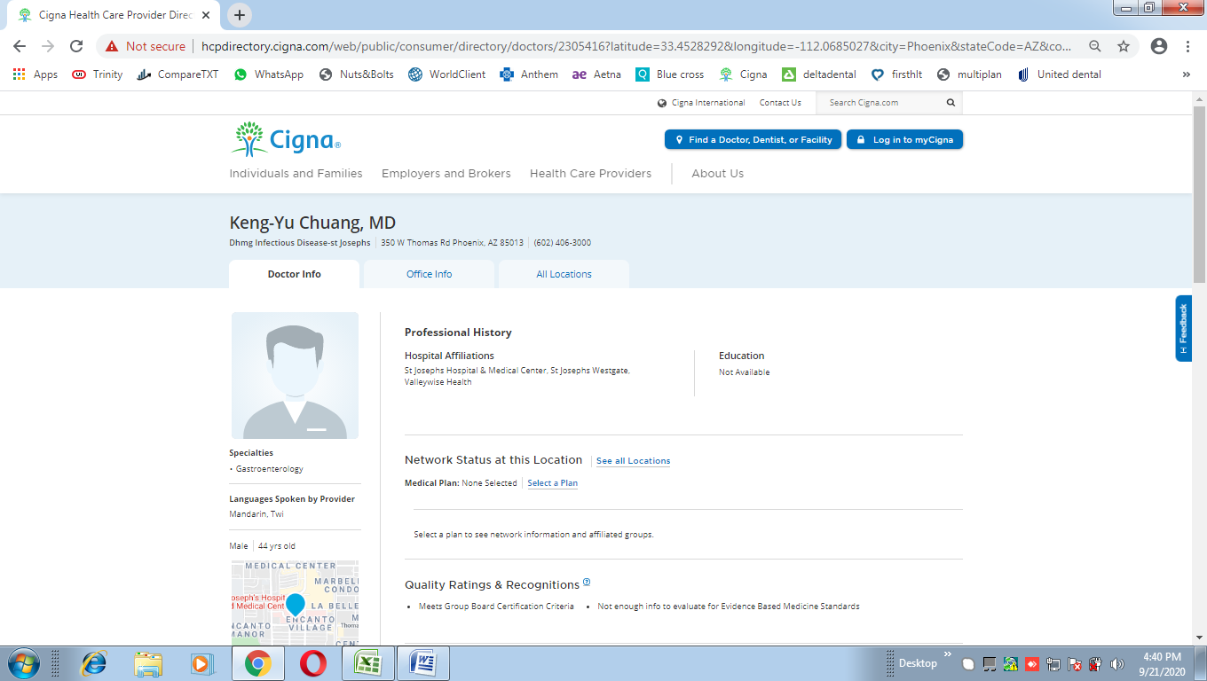
2. Select Dentists (if degree is DMD or DDS) else select Doctors

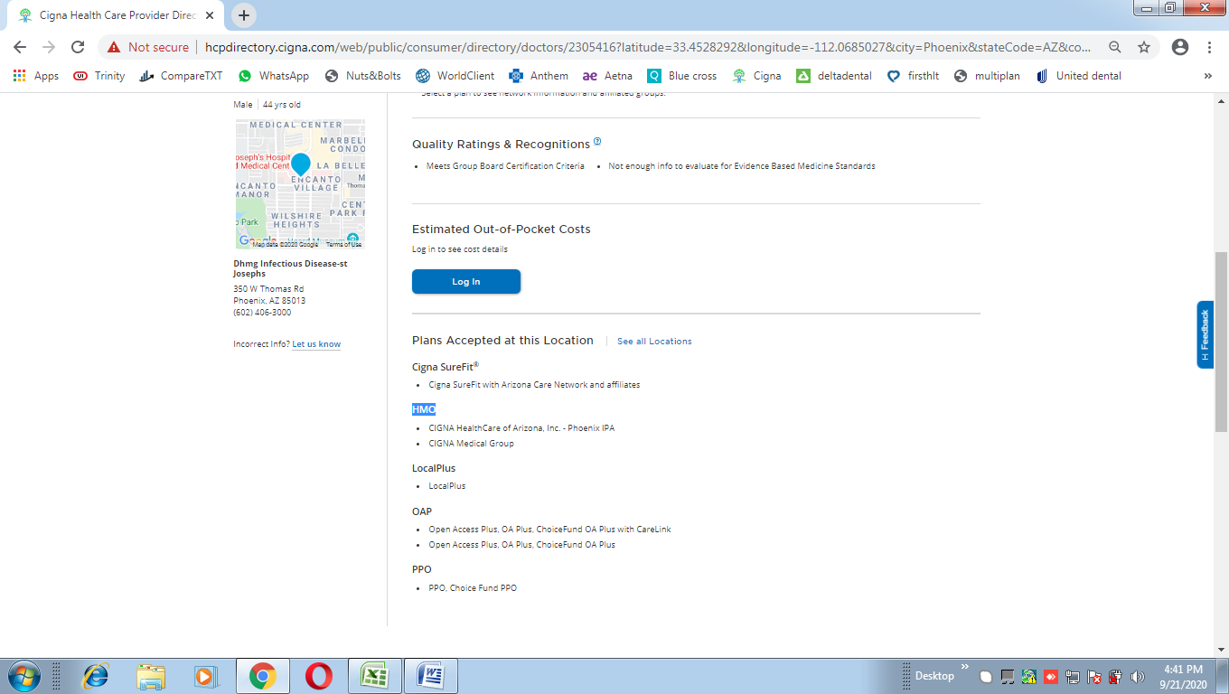

1. After clicking on Dentists (if degree is DMD or DDS) else select Doctors, below window would appear, here we have to click on Continue
2. Insurance plans would be appearing here in BOLD, we have to taken only BOLD headings

Format would be: **Cigna: Cigna Plan name1 | Cigna: Cigna Plan name2 | Cigna: Cigna Plan name3**